Chapter 04.06

Gaussian Elimination – More Examples

Electrical Engineering

Example 1
Three-phase loads are common in AC systems. When the system is balanced the analysis can be simplified to a single equivalent circuit model. However, when it is unbalanced the only practical solution involves the solution of simultaneous linear equations. In one model the following equations need to be solved.
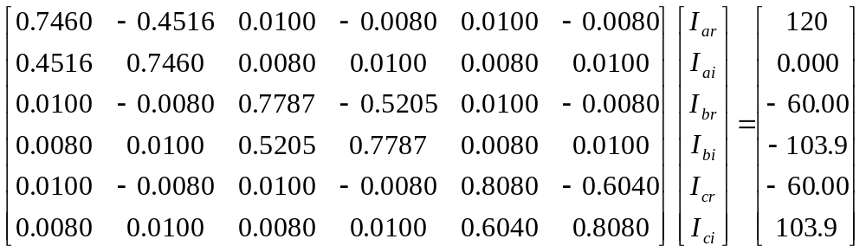
Find the values of 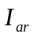, 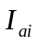, 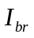, 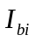, 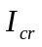, and 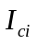 using naïve Gauss elimination.

Solution

Forward Elimination of Unknowns
Since there are six equations, there will be five steps of forward elimination of unknowns.

First step
Divide Row 1 by 0.7460 and multiply it by 0.4516, that is, multiply Row 1 by 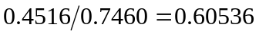.
Subtract the result from Row 2 to get
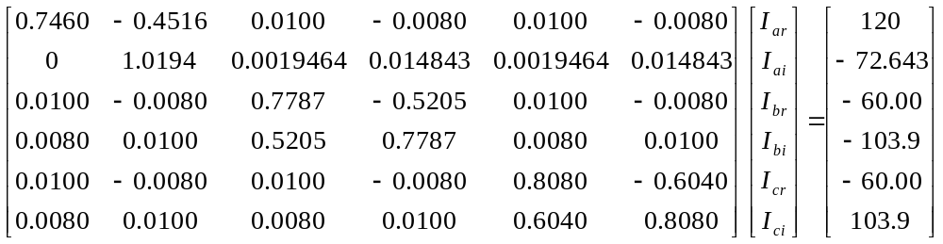

Divide Row 1 by 0.7460 and multiply it by 0.0100, that is, multiply Row 1 by 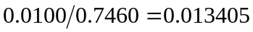.
Subtract the result from Row 3 to get 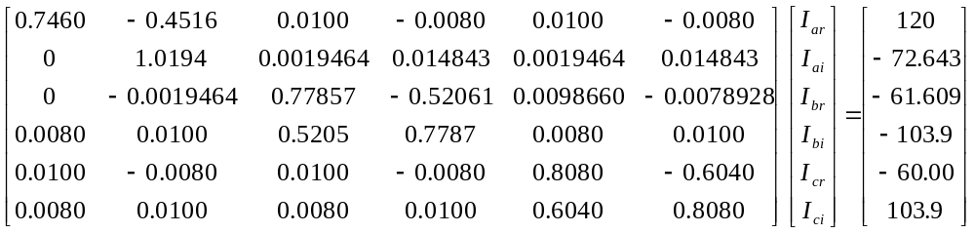
Divide Row 1 by 0.7460 and multiply it by 0.0080, that is, multiply Row 1 by 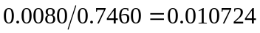.
Subtract the result from Row 4 to get
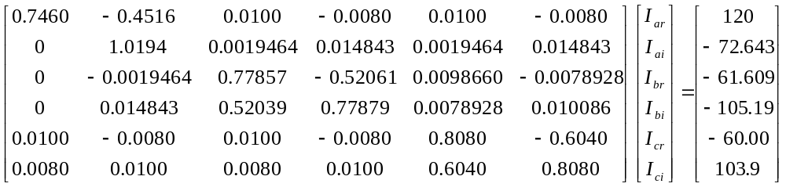
Divide Row 1 by 0.7460 and multiply it by 0.0100, that is, multiply Row 1 by .
Subtract the result from Row 5 to get
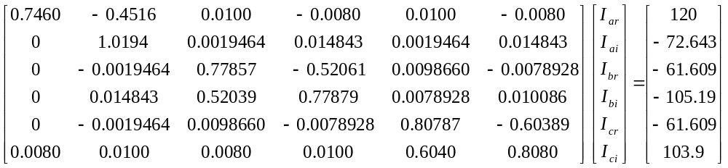
Divide Row 1 by 0.7460 and multiply it by 0.0080, that is, multiply Row 1 by .
Subtract the result from Row 6 to get
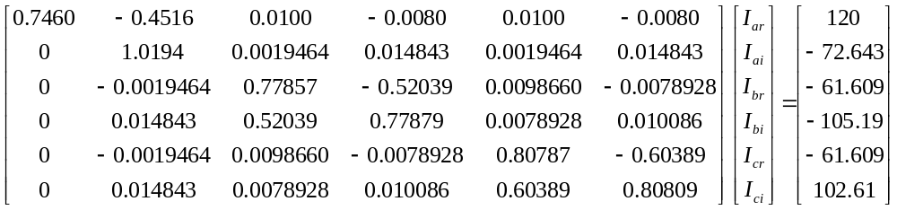
Second step
Divide Row 2 by 1.0194 and multiply it by −0.0019464, that is, multiply Row 2 by .
Subtract the result from Row 3 to get
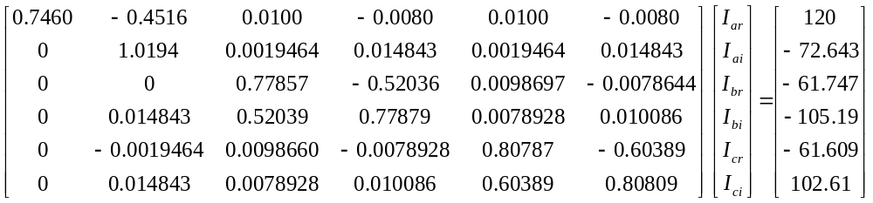
Divide Row 2 by 1.0194 and multiply it by 0.014843, that is, multiply Row 2 by 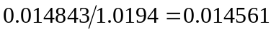.
Subtract the result from Row 4 to get
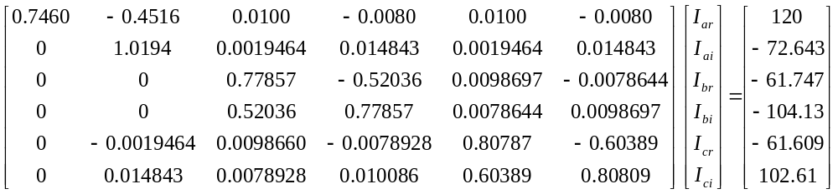
Divide Row 2 by 1.0194 and multiply it by −0.0019464, that is, multiply Row 2 by .
Subtract the result from Row 5 to get
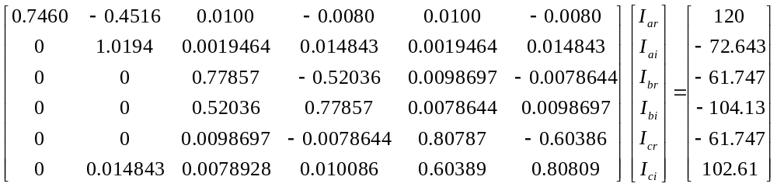

Divide Row 2 by 1.0194 and multiply it by 0.014843, that is, multiply Row 2 by .
Subtract the result from Row 6 to get
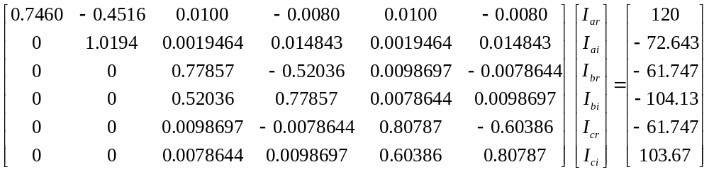

Third step
Divide Row 3 by 0.77857 and multiply it by 0.52036, that is, multiply Row 3 by 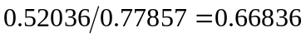.
Subtract the result from Row 4 to get
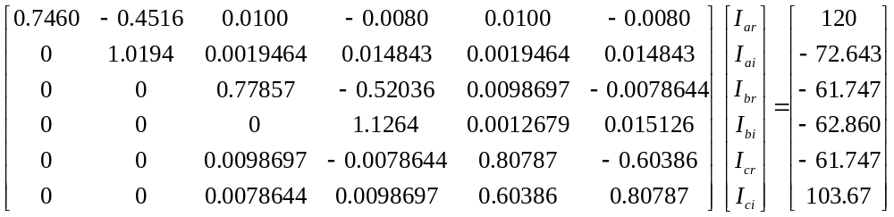

Divide Row 3 by 0.77857 and multiply it by 0.0098697, that is, multiply Row 3 by 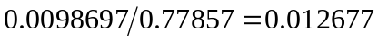.
Subtract the result from Row 5 to get
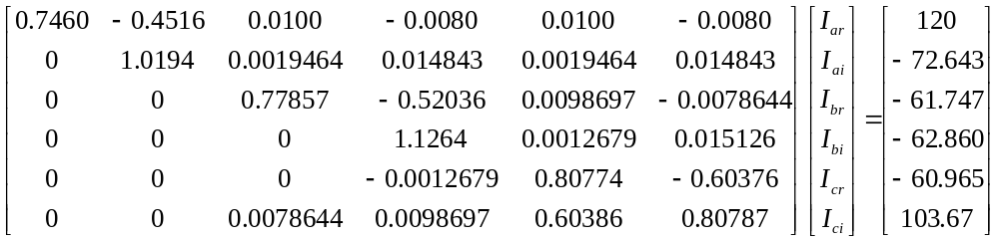

Divide Row 3 by 0.77857 and multiply it by 0.0078644, that is, multiply Row 3 by 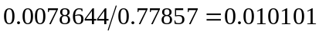.
Subtract the result from Row 6 to get
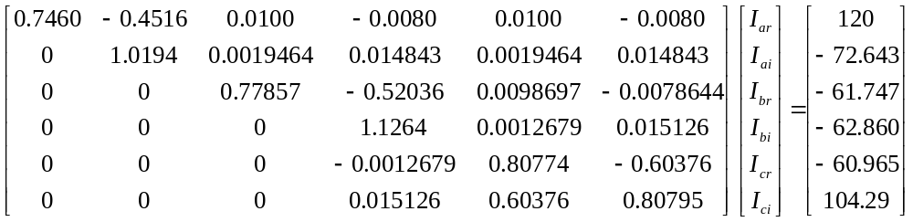

Fourth step
Divide Row 4 by 1.1264 and multiply it by −0.0012679, that is, multiply Row 4 by .
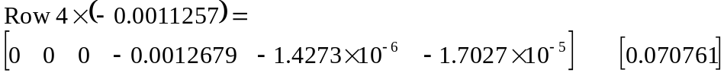
Subtract the result from Row 5 to get
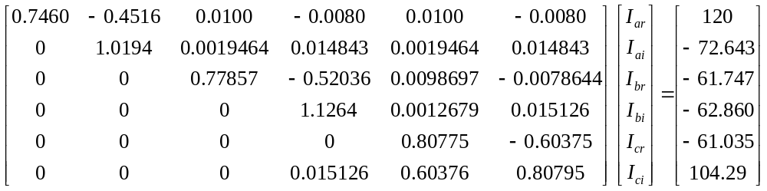

Divide Row 4 by 1.1264 and multiply it by 0.015126, that is, multiply Row 4 by 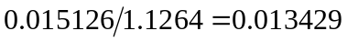.
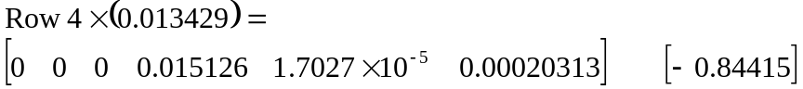
Subtract the result from Row 6 to get
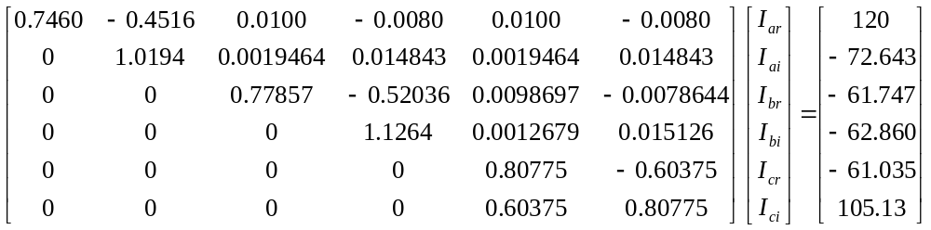

Fifth step
Divide Row 5 by 0.80775 and multiply it by 0.60375, that is, multiply Row 5 by 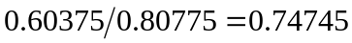.
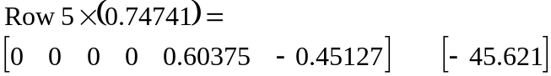
Subtract the result from Row 6 to get
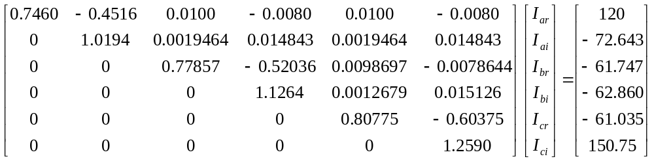

The six equations are
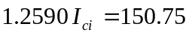

Back Substitution
From the sixth equation
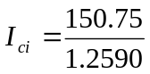
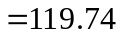
Substituting the value of in the fifth equation,
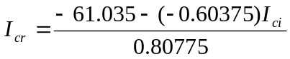
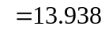
Substituting the value of and in the forth equation,
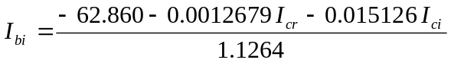
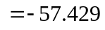
Substituting the value of , and in the third equation,
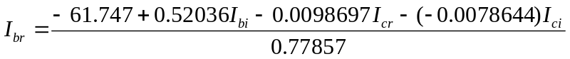
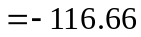
Substituting the value of , , and in the second equation,
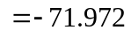
Substituting the value of , , , , and in the first equation,
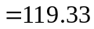
Hence the solution vector is
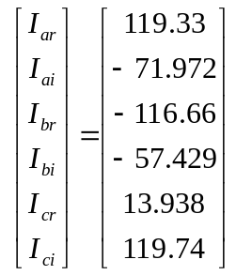

SIMULTANEOUS LINEAR EQUATIONS
Topic | Gaussian Elimination – More Examples
Summary | Examples of Gaussian elimination
Major | Electrical Engineering
Authors | Autar Kaw
Web Site | http://numericalmethods.eng.usf.edu

